**Pusher Dynamic Step Document**

Objective

Pusher Channels provides real-time communication between servers, apps, and devices. Pusher Channels is used for notifications, chat, gaming, web-page updates, IoT, and many other systems requiring real-time communication.

UI

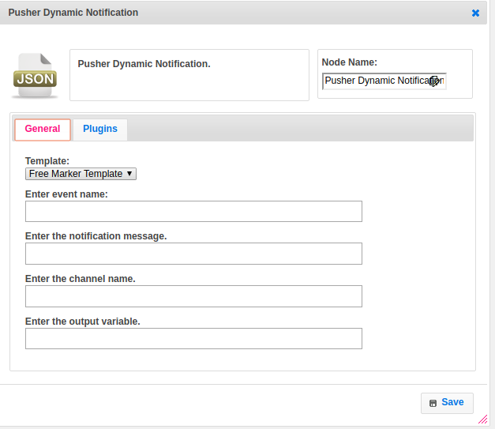

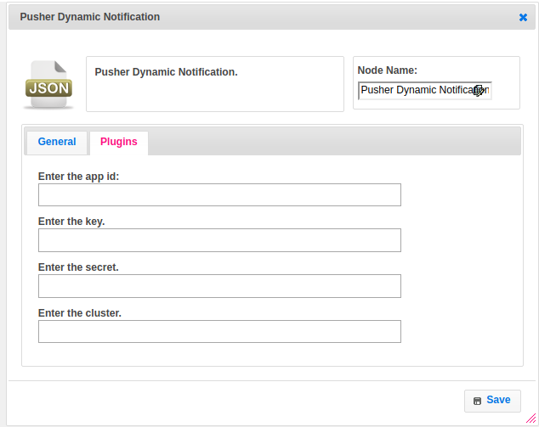

Attributes

|  |  |
| --- | --- |
| **Attributes** | **Description** |
| **1. Template** | Value type used to set the value type. Value types are two types.  1.hb-HandleBars  2.ftl-Freemarker Template Language. |
| **2. Enter event name** | The name of the event to bind to.Events are the primary method of packaging messages in the Channels system. they form the basis of all communication. |
| **3. Enter the notification message** | A message having information to provide the notification when the event trigger. |
| **4. Enter the channel name** | Provide the name of the channel.Each application can one channel or many, and each client can choose which channels it subscribes to. |
| **5. Enter pusher notification plugin name** | Provide the plugin, which contains the plusher configurations.For more details about plugin please refer the information which is provided in Dependent plugin. |
| **6. App Id** | The application key is a string which is globally unique to your application. It can be found in the API Access section of your application within the Channels user dashboard. |
| **7.Key** | Your application key, to provide the access. |
| **8.Cluster** | The identifier of the cluster your application was created in. When not supplied, will connect to the mt1 (us-east-1) cluster. |
| **9.Secret** | All interactions with the Channels HTTP API must contain an authentication signature that is generated with your secret key. |
| **10.Output variable** | To store the response |

## **Executor Description**

Call the pushMessage method by passing the channel name, event name, and message. Initialize the pusher plugin. Call the trigger method of Pusher API class. This method send the notification on specific channel and event name with notification obj.

## **Resource**

Please refer the following link for more information.

<https://pusher.com/docs/client_api_guide/client_events>